VPC Challenges
Use Case: Setting up Transit Gateway and VPC Endpoints for a Multi-VPC Architecture
Scenario:
A large organization is migrating its on-premises infrastructure to the AWS cloud.
The organization's architecture involves multiple VPCs for different departments and applications, each requiring secure communication with centralized services and external resources.
The IT team needs to design and implement a scalable and efficient network architecture to accommodate the organization's growth and ensure robust connectivity between VPCs and external services.
Objectives:
- Design and deploy a scalable network architecture using AWS Transit Gateway to simplify network connectivity between multiple VPCs.
- Configure VPC endpoints to securely access AWS services without internet gateways or NAT gateways, ensuring data privacy and minimizing exposure to external threats.

Setting up transit gateway
it is a network hub that allows you to connect multiple vpc’s and networks using single gateway instead of creating many vpc peerings
first go to vpc
create multiple vpc’s
go to subnets and create multiple subnets
go to internet gateway and create multiple internet gateways accordingly and attach to each vpc
go to route table and create multiple route tables and add each subnet to each route table and do subnet associations
create the transit gateway
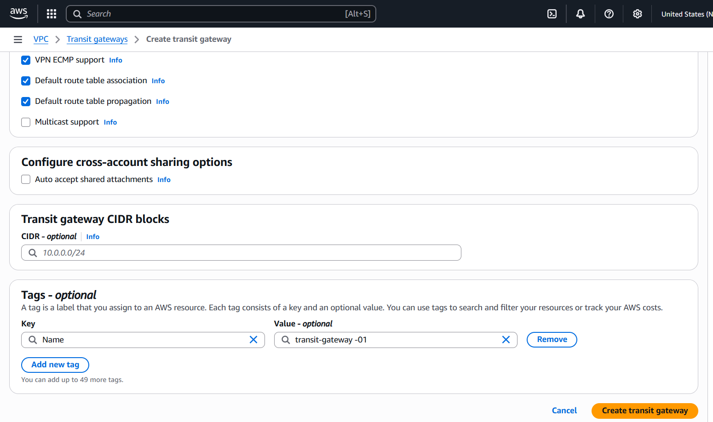
create multiple transit gateway attachments and add the vpc to each
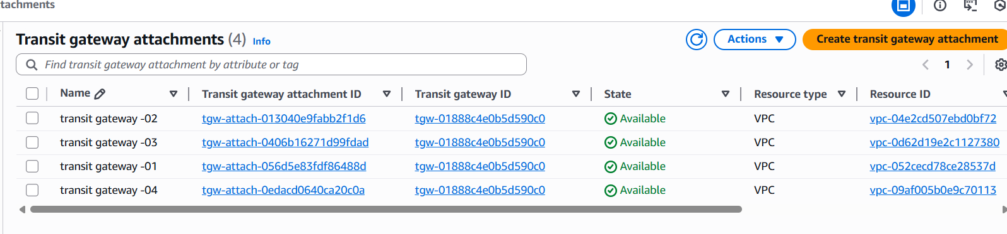
now go to route tables and add each vpc cidr range and give transit gateway access’
now create multiple ec2 instances and add each subnet accordingly and launch the instances
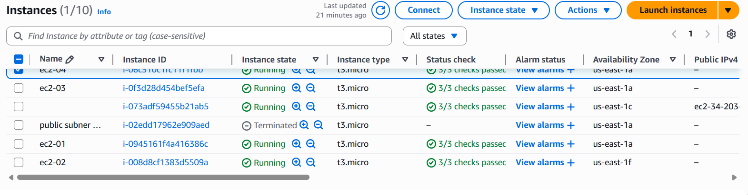
now in git bash connect one instance by adding security group permissions ,should give all traffic
with custom 0000
now connect with ec2 instance -01 and copy the ec2 private ip
now run the command ping ec2-02 private ip of ec2
check the same with all instances with different instance private ip’
run with different private ip’s from different instances
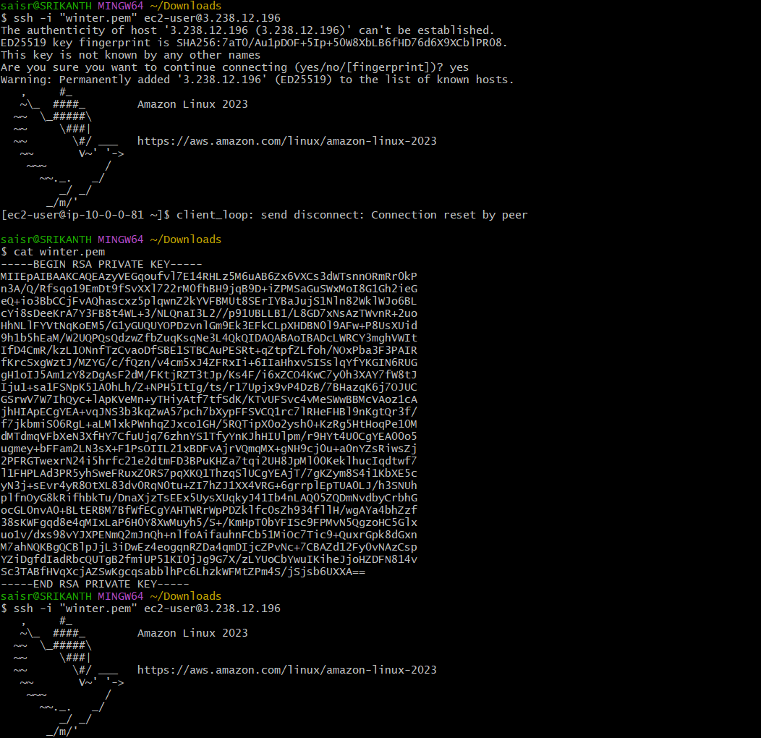
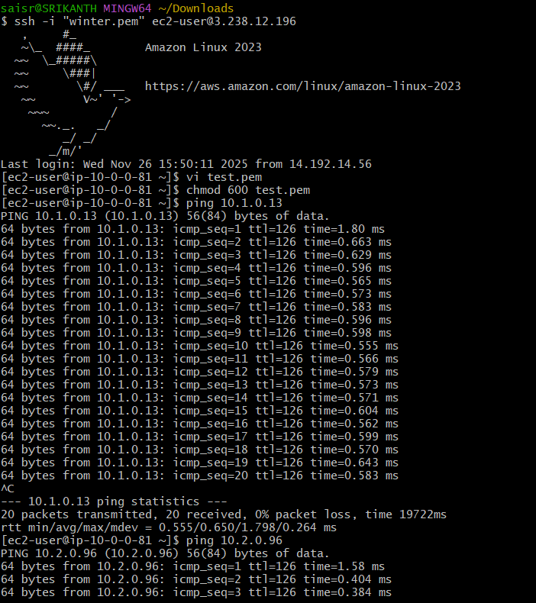
Set up VPC end point
- it allows ec2 instances in private subnet to access aws services like s3 without using the internet or nat gteway or public ip

- first create one vpc,public subnet and private subnet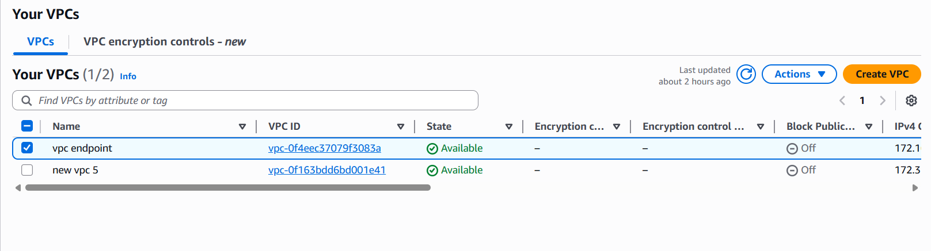 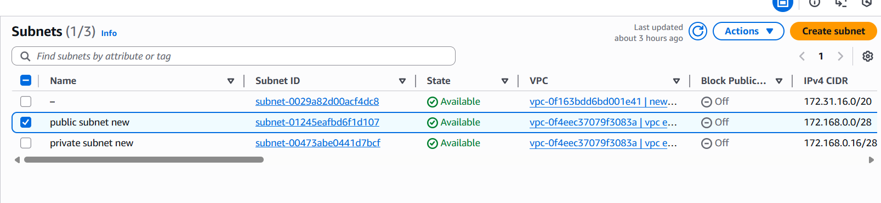

create 2 route tables public and private and add subnet association accordingly
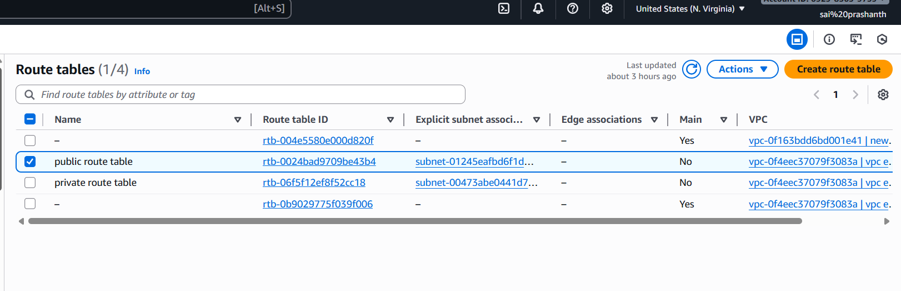
create the internet gateway and attach the vpc and make changes in the route table by adding with ig id
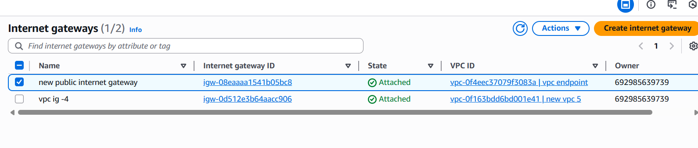
now create a bucket in s3 by adding the unique name
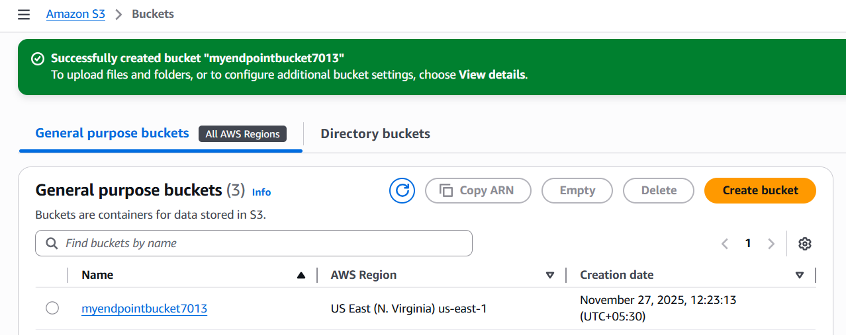
before creating the instance download the access key and secret key for getting the aws configure
go to security credentials
click on it
select the access key and secret key
download the file

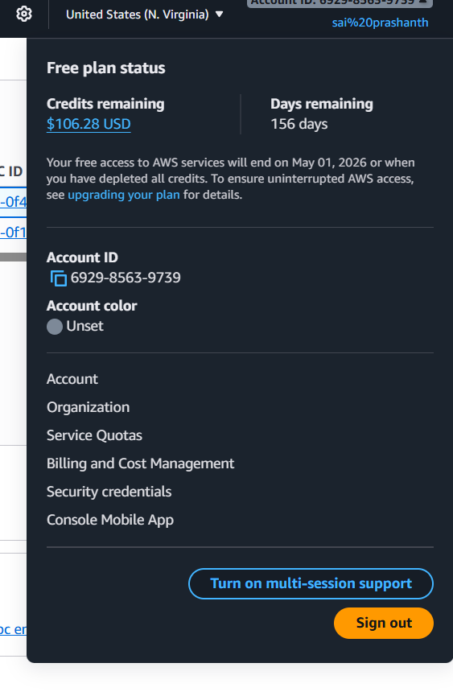
now create two instances one for public and one for private
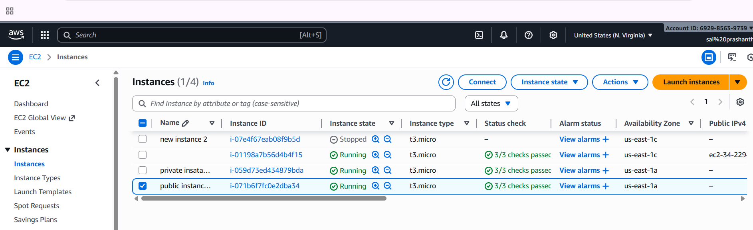
connect with public instance ssh -i……
now aws configure
enter access key
secret key
region
output format -json
now to list the buckets
aws s3 ls
you can see the buckets list
now to connect with private ip with private instance
copy your pemkey data
and paste it in vi test.pem
and add permissions chmod 600 test.pem
ssh -I test.pem ec2-user@private ip
now if do aws configure and aws s3 ls
it doesn’t display – reason is that private instance didn’t have internet access or nat gateway access and there is no way of knowing if s3 bucket exists
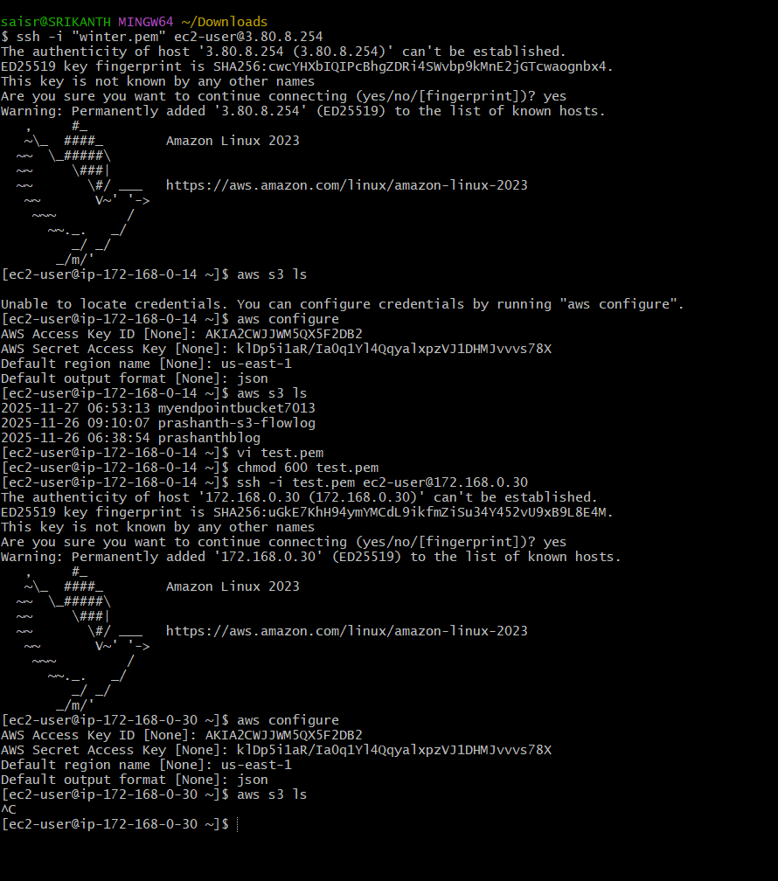
now creating the end point
select endpoint-create end point—provide one end point name—select the type AWS services—select the region—select the service s3—select the service type gateway—select vpc—in route table select the private route table—policy select full access and create the end point.
finally end point has been created
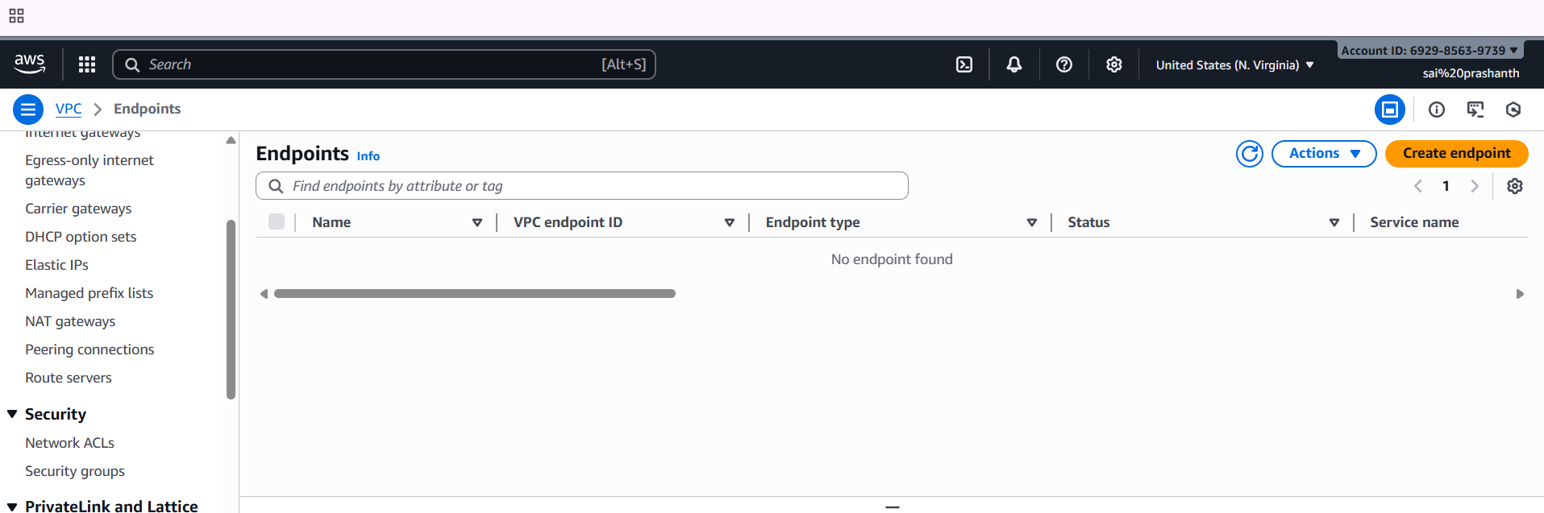
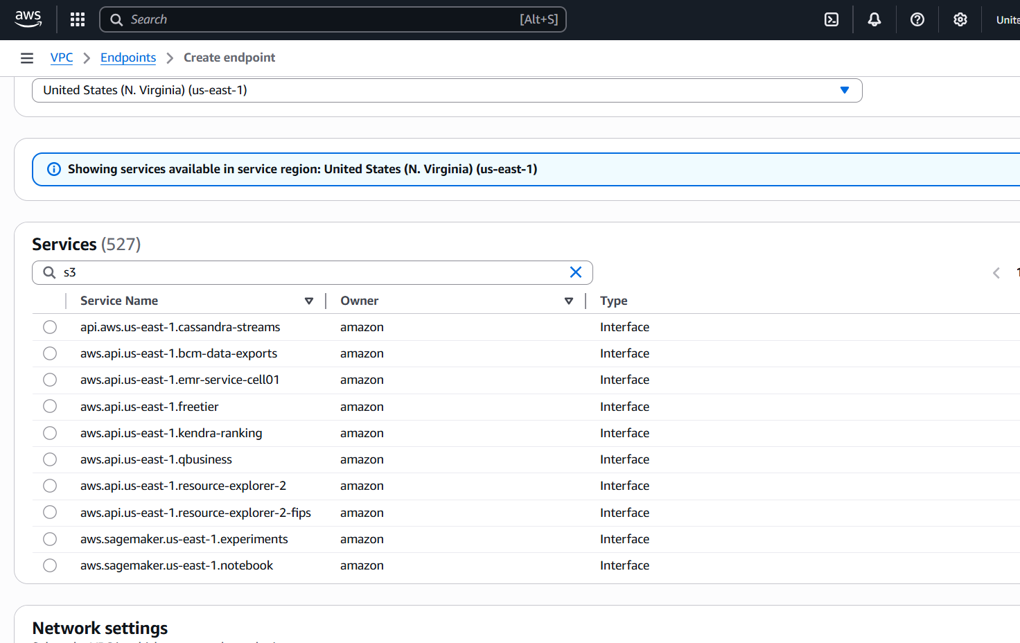
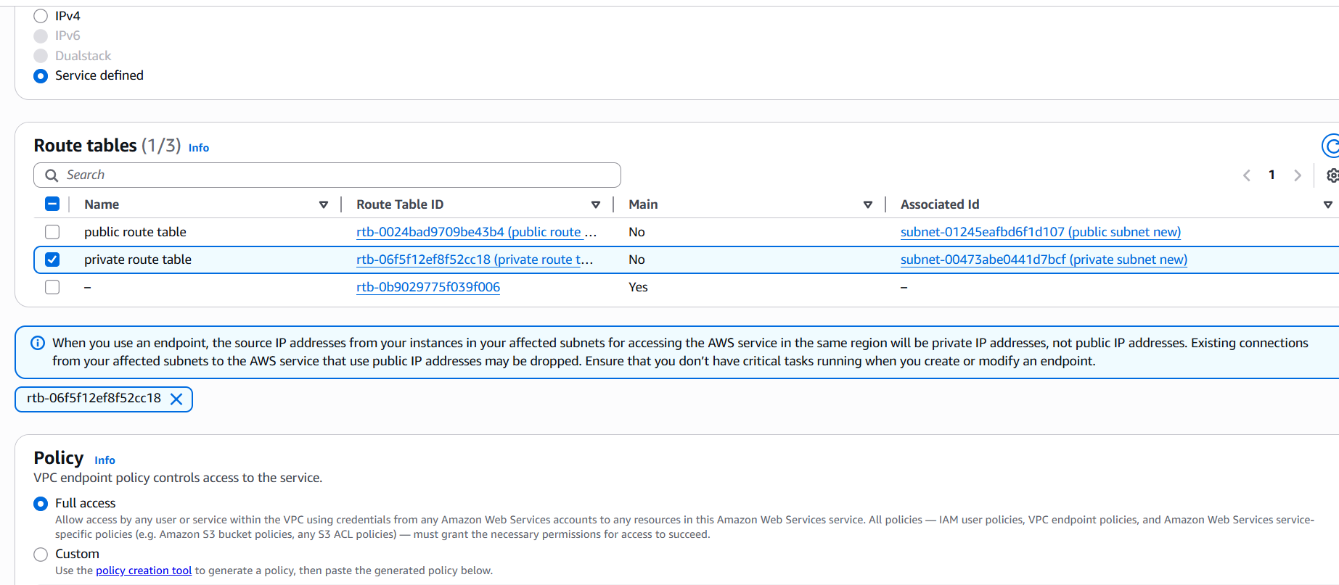
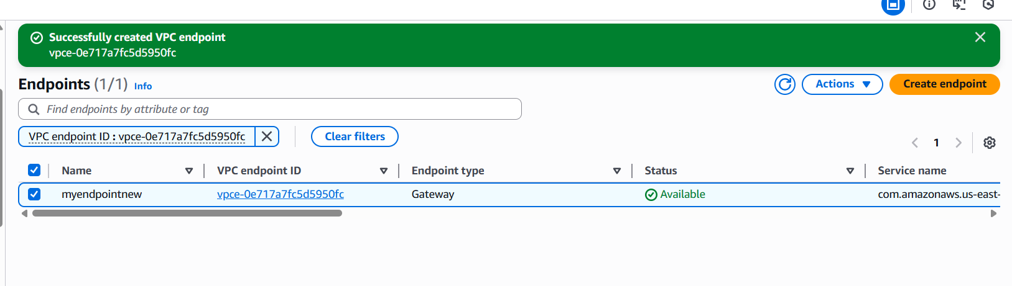
now try to connect in git bash
try to access with private ip now
now we have established private connection to end point so we can see the s3 bucket list
aws s3 ls
